**Linear approximations revisited**

You already know how to take linear approximations. This was the main tool for finding the derivatives of all of the basic functions in the previous unit.

We return again to linear approximations because they are the main tool that we use in finding approximations in science and engineering. Here we develop some more tools for using linear approximations. We will also change our perspective and use linear approximations to estimate how measurement error propagates through a system, and understand the system's sensitivity to small perturbations.

**Zipline design problem setup**

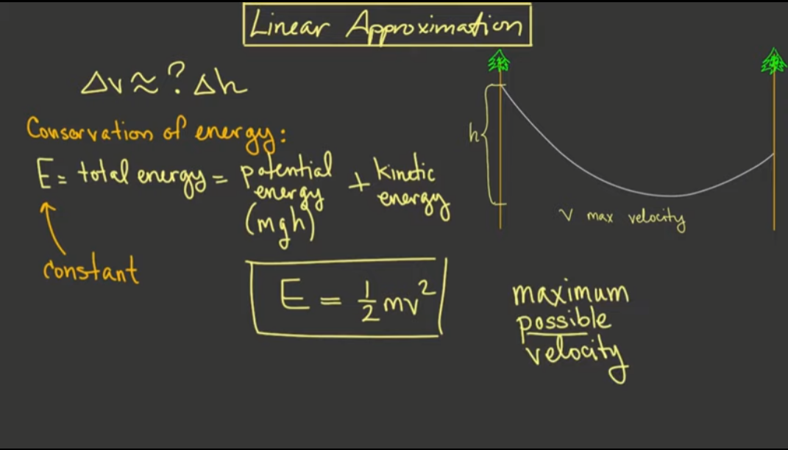

### Find the maximum velocity

